**Central Limit Theorem**

The central limit theorem states that if you take sufficiently large samples from a population, the samples’ means will be normally distributed, even if the population isn’t normally distributed.

A population follows a Poisson distribution (left image). If we take 10,000 samples from the population, each with a sample size of 50, the sample means follow a normal distribution, as predicted by the central limit theorem (right image).

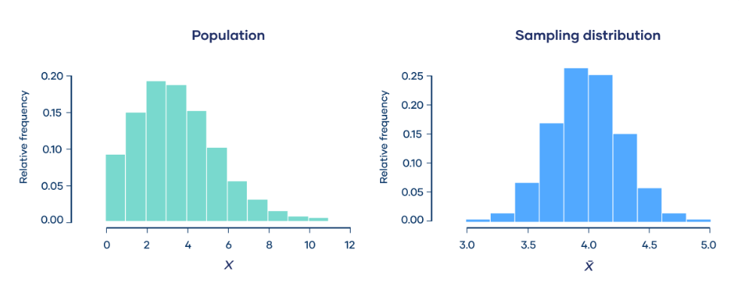

The central limit theorem says that the **sampling distribution of the mean will always be normally distributed**, as long as the sample size is large enough. Regardless of whether the population has a normal, Poisson, binomial, or any other distribution, the sampling distribution of the mean will be normal

**Conditions of the central limit theorem**

1. The sample size is **sufficiently large**. This condition is usually met if the sample size is n ≥ 30.
2. The samples are **independent and identically distributed** (i.i.d.) random variables. This condition is usually met if the sampling is random.
3. The population’s distribution has **finite variance**. Central limit theorem doesn’t apply to distributions with infinite variance, such as the Cauchy distribution. Most distributions have finite variance.